Ms. Blackmore’s final resting place
Front | Left Side | Right Side | Back
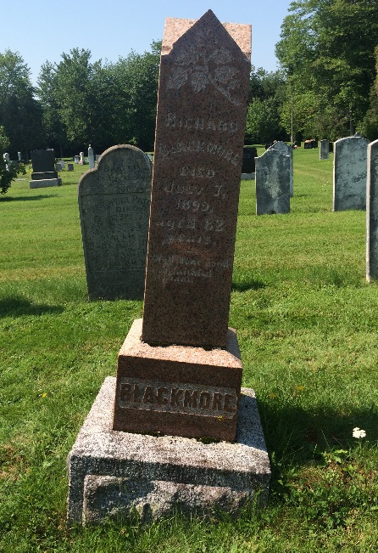 | 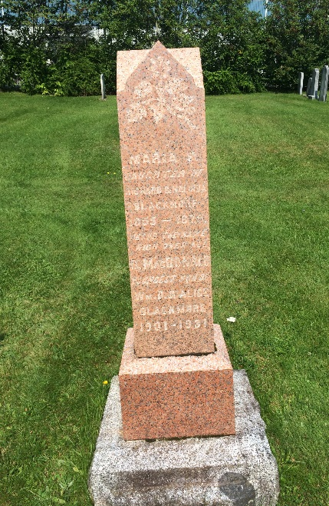 | 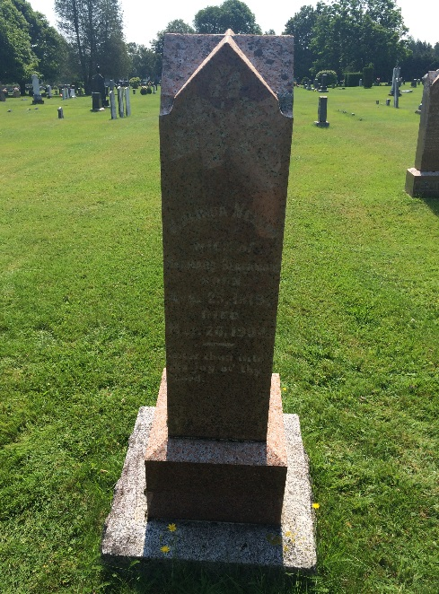 | 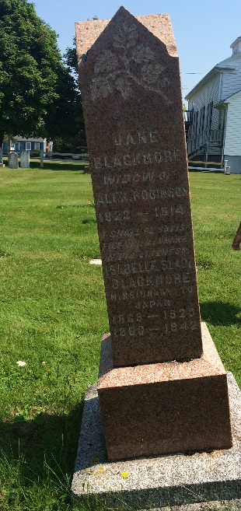
Richard Blackmore (father)  Died July 7,1899  aged 82  “Well done, good and faithful servant.” | Maria F. (sister)  Daughter of Richard and Malinda Blackmore  1855-1879  “Jesus the name high over all.”  D. MacDonald (nephew)  Youngest son of Wm D. An Alice Blackmore  1901-1931 | Malinda Nelson (mother)  Wife of Richard Blackmore  Born Apr 25, 1819  Died Mar. 26, 1904  “Enter thou into the joy of thy lord.” | Jane Blackmore (aunt)  Widow of Alex Robinson  1822 – 1914  “I shall be satisfied when I awake in his likeness.”  Isabelle Slade Blackmore  Missionary to Japan  1889 - 1925  1863 - 1942
